

Desh Bhagat Engineering College
HSSN
Individual Assignment
(PT0881122)

Date assigned: - 9 oct, 2015 Due Date: -9 NOV, 2011

SUBMITTED BY: SUBMITTED TO
AWADHESH KUMAR SHARMA Er. Khusbu Bansal
(Lecturer)

Table of Contents

1.0 Introduction 3
2.0 Requirement Analysis 4
3.0 Network ^{[1]} 5
4.0Advantages/Disadvantages of Computer Networks ^{[3]} 5
4.1 Advantages of Computer Networks 5
4.2 Disadvantages of Computer Networks 6
5.0 Internet connection option ^{[4]} 7
6.0WAN Connection Options 8
7.0 Network Topology Analysis ^{[5]} 9
8.0 Network Architecture Analysis 12
9.0 Transmission Media Analysis 13
10.0 Analysis of Research 14
11.0 Network Design 15
11.1LAN 1 – Head Quarter, Kauala Lumpur, Malaysia 15
11.2 LAN 2– Branch office, Bangkok, Thailand 16
11.3 LAN 3– Branch office, Delhi, India 17
11.4 Most Suitable Topology 18
11.5 Most Suitable Architecture: Client-Server Architecture 20
11.6 Most Suitable Transmission Media 21
11.7 WAN Design 23
11.8 Most Suitable networking device 26
12.0 Cost Estimation 31
13.0 Problems Expected With the Network 32
14.0 Future Enhancement 32
15.0 Conclusion 33
16.0 References 34

1.0 Introduction

ICT Resources Malaysia Public Limited is one of the well-known companies within South East Asia. It supplies business equipment. Some time before, there was no competitor but now a nationally recognized competitor opened for business with plan to put ICT resource out of business which made the ICT Resource Malaysia Public Limited a reason to think. For this ICT Resource is going to invest a major sum of money in the business to fixedly establish itself within the current scenario of competitive competition.
ICT Resources locally owns a 2 storey building and currently has already grown to a level where they now have resources of 35 staff and this figure is still growing. They have developed and spread their business to 3 strategic locations throughout South East Asia with more upcoming offices in other locations planned for 2012. These new offices will incorporate the retail concept coupled with local sales offices.

2.0 Requirement Analysis
As ICT resources Malaysia specifies, it requires a very reliable and secure network with very strong backbone. They want that information should be transferred and communicated on a very high scale between employees in the premises and the employees of the other locations also.
Scenario:
- ICT Resources locally owns a 2 storey building and currently has already grown to a level where they now have resources of 30-35 staff.
- They have developed and spread their business to 3 strategic locations throughout South East Asia
- The goal is to determine the type of network topology they will need within the office.
- Company network should be centrally manageable and highly scalable.
- Security and privacy is the big concern for the company.

Assumptions
- There are two floors in one premises of the company, so all the floors are not enough far away from each other.
- The company wants to invest huge amount of money to make its network scalable and highly reliable.
- There peripherals are used inside the premises (not wireless).
- The employees of the company will use network mainly for information transfer to incorporate the retail concept coupled with local sales offices.

Task description
- Recommend the type of network which is best suited for the company

- Recommend the network topology which suits the requirement of the company

- Recommend the transmission media which can be used

- Provide the types of expected problems which may occur with a network

3.0 Network ^{[1]}
A network is a series of points or nodes interconnected by communication paths. Networks can interconnect with other networks and contain sub networks.
Networks can also be characterized in terms of spatial distance as local area networks (LANs), metropolitan area networks (MANs), and wide area networks (WANs).^{[2]}

3.1LAN - Local Area Network
A LAN connects network devices over a relatively short distance. A networked office building, school, or home usually contains a single LAN, though sometimes one building will contain a few small LANs (perhaps one per room), and occasionally a LAN will span a group of nearby buildings.

3.2Metropolitan Area Network
It is a network spanning a physical area larger than a LAN but smaller than a WAN, such as a city. A MAN is typically owned and operated by a single entity such as a government body or large corporation.

3.3WAN - Wide Area Network
As the term implies, a WAN spans a large physical distance. The Internet is the largest WAN, spanning the Earth. A WAN is a geographically-dispersed collection of LANs. WANs tend to use technology like ATM, Frame Relay and X.25 for connectivity over the longer distances.

4.0Advantages/Disadvantages of Computer Networks ^{[3]}
4.1 Advantages of Computer Networks
- File Sharing: computer network allows file sharing and remote file access. A person sitting at one workstation of a network can easily see the files present on the other workstation, provided he is authorized to do so.
- Resource Sharing: Resource sharing is also an important benefit of a computer network. For example, if there are four people in a family, each having their own computer, they will require four modems (for the Internet connection) and four printers and if they are using a network, and just one modem and printer can efficiently provide the services to all four members. The facility of shared folders can also be availed by family members.
- Increased Storage Capacity: As there is more than one computer on a network which can easily share files, the issue of storage capacity gets resolved to a great extent
- Increased Cost Efficiency: Software can be shared amongst different users.
- Terminals are cheaper than standalone PCs.
- Communication across the network is cheap and fast.

4.2 Disadvantages of Computer Networks
- Security Issues: One of the major drawbacks of computer networks is the security issues involved. If a computer is a standalone, physical access becomes necessary for any kind of data theft. However, if a computer is on a network, a computer hacker can get unauthorized access by using different tools.
- Rapid Spread of Computer Viruses: If any computer system in a network gets affected by computer virus, there is a possible threat of other systems getting affected too. Viruses get spread on a network easily because of the interconnectivity of workstations. Such spread can be dangerous if the computers have important database which can get corrupted by the virus.
- Expensive Set Up: The initial set up cost of a computer network can be high depending on the number of computers to be connected. Costly devices like routers, switches, hubs, etc., can add up to the bills of a person trying to install a computer network.
- Dependency on the Main File Server: In case the main File Server of a computer network breaks down, the system becomes useless. In case of big networks, the File Server should be a powerful computer, which often makes it expensive.

5.0 Internet connection option ^{[4]}
- Dialup - typical modem speed 56K (usually connects at between 40 and 50 K) Connecting to the Internet with a dial-up modem is one of the oldest and simplest methods. It is used primarily in homes and by small businesses. It is the least expensive method, but with the low price comes very limited performance.
- DSL - A digital subscriber line (or DSL) connection is a widely used method of accessing the Internet for homes and small businesses; it provides faster download of files without the wait associated with dial-up.
- Cable Modem (via your cable TV provider), they offer the same benefits of DSL, including fast upload and download speeds, an “always on” connection, and similar pricing. Instead of a phone line, cable modems are connected through coaxial cable (the same lines that provide cable television feeds)
- Satellite connection-it is a good option for homes or offices that do not have access to DSL or cable (as can be the case with certain very remote locations). Satellite dishes require a clear line of sight to the satellite
- ISDN - not cost effective for home use, but a more reliable connection.
- T1 Lines - These are standard among medium and large businesses. They’re also extremely reliable and high-performing, and are usually accompanied by excellent support services.
- Wireless connections (for cell phones and notebooks).

6.0WAN Connection Options

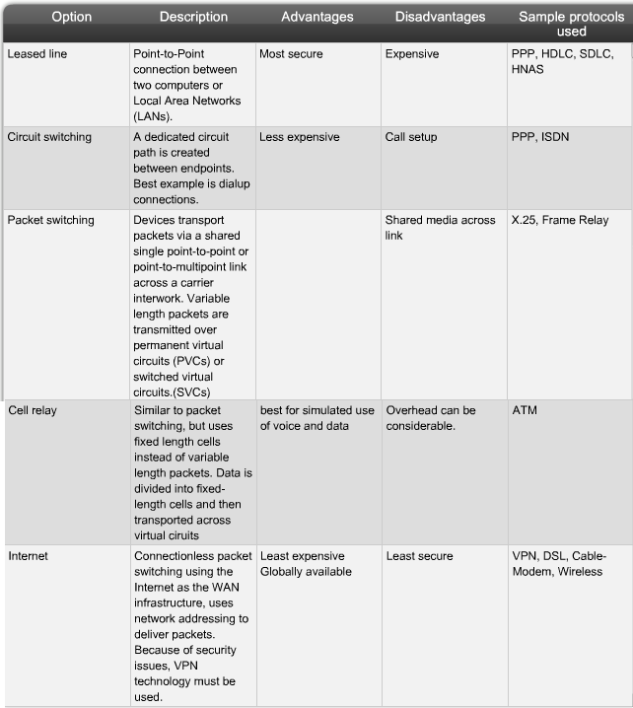

Fig 1- Different type of WAN connection option

7.0 Network Topology Analysis ^{[5]}
Topology of the network is defined as the physical arrangement or relationship of the network devices and interconnections between them. There are basically six types of topologies which are following:
7.1Bus Topology: Bus topology consists of a main run of cable with a terminator at each end. All nodes (file server, workstations, and peripherals) are connected to the linear cable.
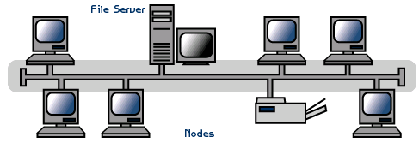
7.2 Star Topology: in this topology nodes are connected to common central hub or switch and this is done by the use of dedicated links.
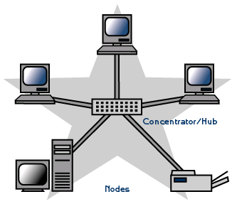
7.3 Ring Topology: The ring topology is a type of computer network configuration where each network computer and device is connected to each other forming a large circle (or similar shape).
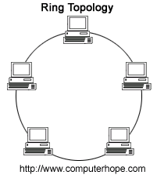
7.4 Mesh Topology: in mesh topology each device is connected with point to point dedicated link where each node is capable of transmitting, receiving, and routing the data.
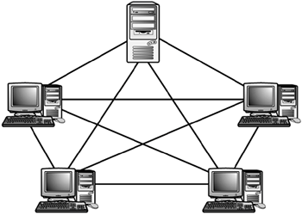
7.5 Tree Topology: It is the combination of Bus and star topology. It is the combination of groups of star configured workstations connected with a dedicated backbone cable.
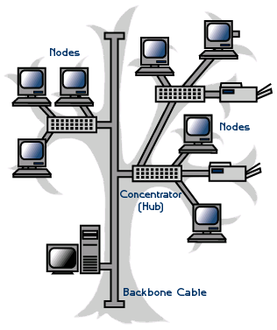
7.6 Hybrid Topology: A hybrid topology is a combination of any two or more network topologies in such a way that the resulting network does not have one of the standard forms.
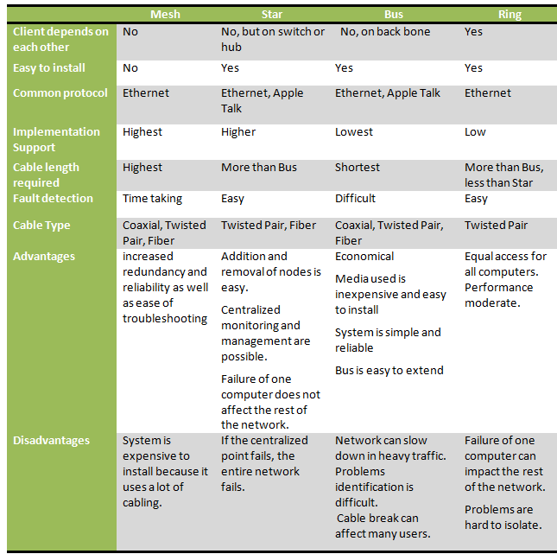
7.7 Comparison of Topologies:
Table 1- Comparison of different topology

8.0 Network Architecture Analysis

8.1Client Server Architecture ^{[6}]
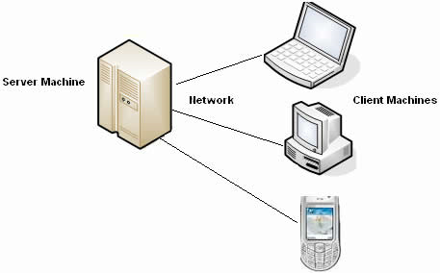
A network architecture in which each computer or process on the network is either a client or a server. Servers are powerful computers or processes dedicated to managing disk drives (file servers), printers (print servers), or network traffic (network server). Clients are PCs or workstations on which users run applications. Clients rely on servers for resources, such as files, devices, and even processing power.

Figure.2- Client Server Architecture

8.2Peer to peer
Peer-to-peer (P2P) computing or networking is a distributed application architecture that partitions tasks or workloads between peers. Peers are equally privileged, equipotent participants in the application. They are said to form a peer-to-peer network of nodes.
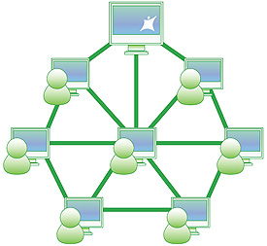
Peers make a portion of their resources, such as processing power, disk storage or network bandwidth, directly available to other network participants, without the need for central coordination by servers or stable hosts. Peers are both suppliers and consumers of resources, in contrast to the traditional client–server model where only servers supply, and clients consume

Figure3: Peer-to-Peer Architecture

9.0 Transmission Media Analysis
The means through which data is transformed from one place to another is called transmission or communication media. There are two categories of transmission media used in computer communications.
9.1 Bounded Media
Bounded media are the physical links through which signals are confined to narrow path. These are also called guide media. Bounded media are made up o a external conductor (Usually Copper) bounded by jacket material. These are
- Coaxial Cable
- Twisted Pairs Cable
- Fiber Optics Cable
9.2 Unbounded Media
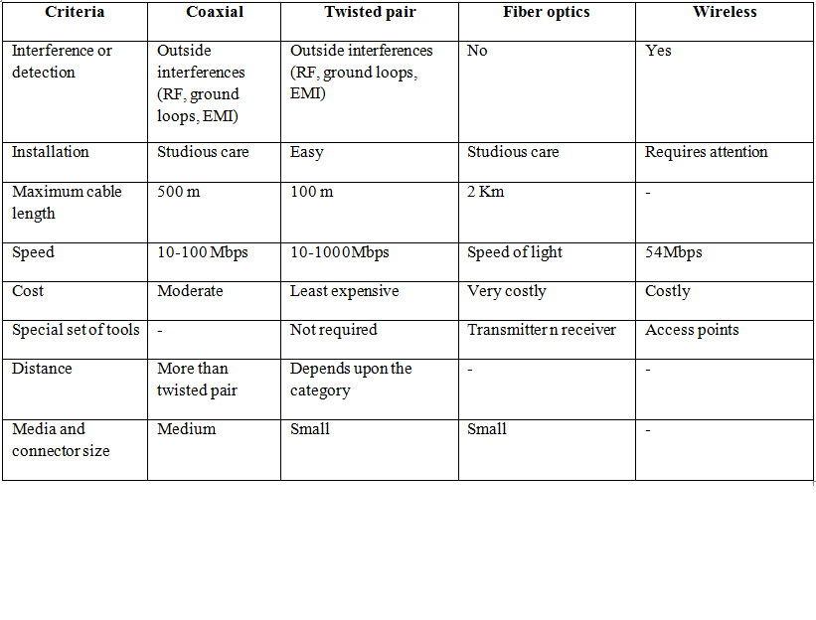
Unbounded media does not require a physical link. Transmission of signals is done in the form of electromagnetic signals. For example- Wireless media.
Table2- Comparison of different media type

10.0 Analysis of Research

1. | Transmission Media | Guided media | It is most reliable than Unguided
2. | Cable used | Twisted Pair | As it is easiest to handle
3. | Category of cable | Category 5 and 5 e | Cheaper and high speed up to 1000 Mbps speed
4. | Network Model | Client- Server model | Centralized Server& Maintained by System Administrator
7. | Topology | Star Topology and Hybrid(Star +Mesh) | Star- Scalable, faster and less cabling  Hybrid- more reliable
9. | WAN Connection Type | AT&T Frame-relay network | Most reliable and cheapest for distant communication
10. | Connectors | RJ - 45 Male& RJ – 45 Female | Used along with Twisted Pair cables
Table3- Analysis Result

Note – Detail justification will be given in later section

11.0 Network Design

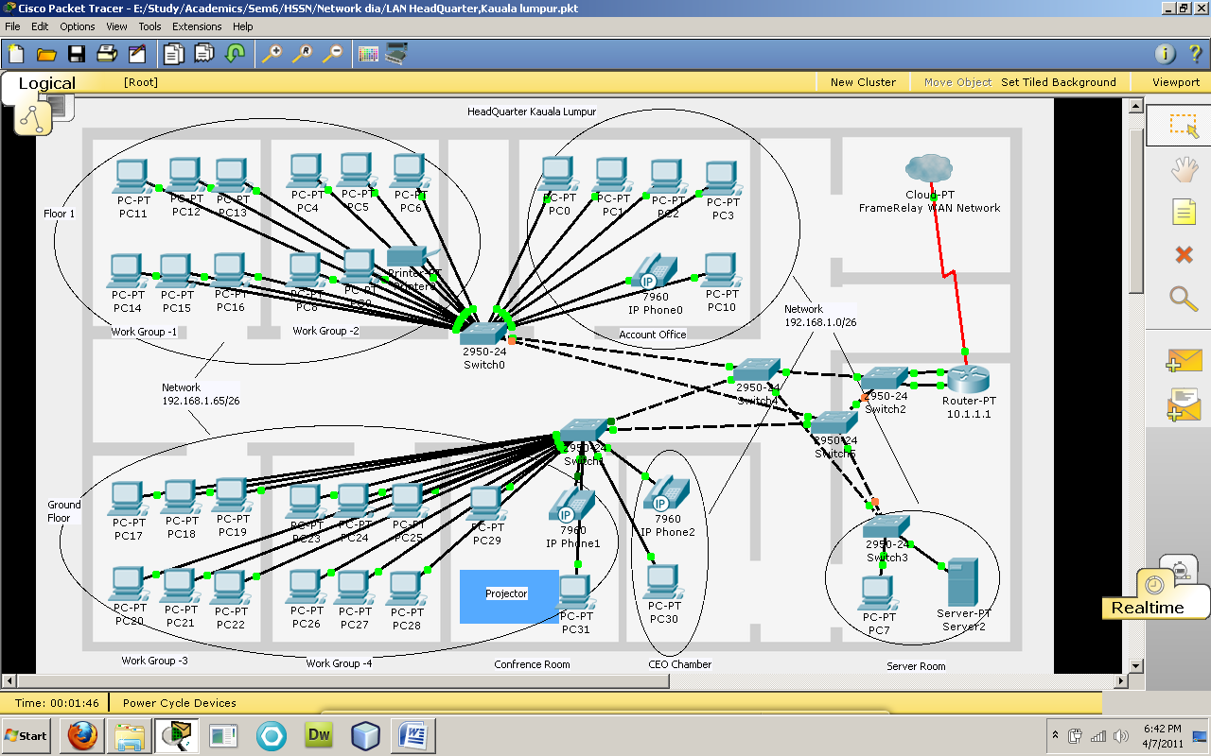
11.1LAN 1 – Head Quarter, Kauala Lumpur, Malaysia

Figure4. Headquarter LAN ,Kauala Lumpur ,Malaysia

11.2 LAN 2– Branch office, Bangkok, Thailand

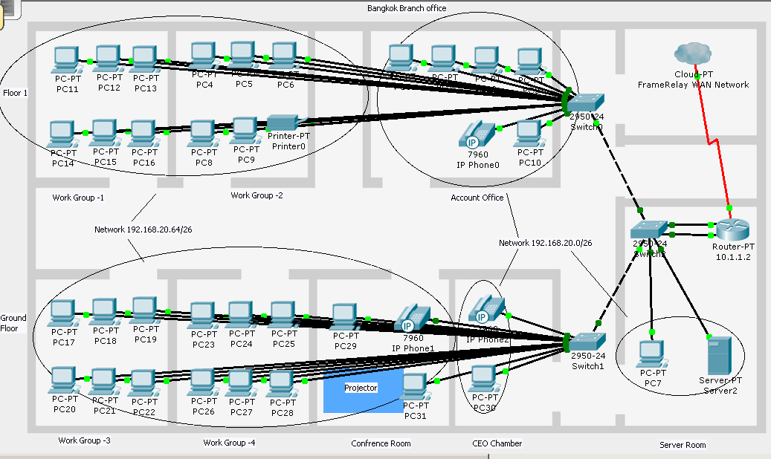
Figure5.Branch office LAN ,Bangkok ,Thailand

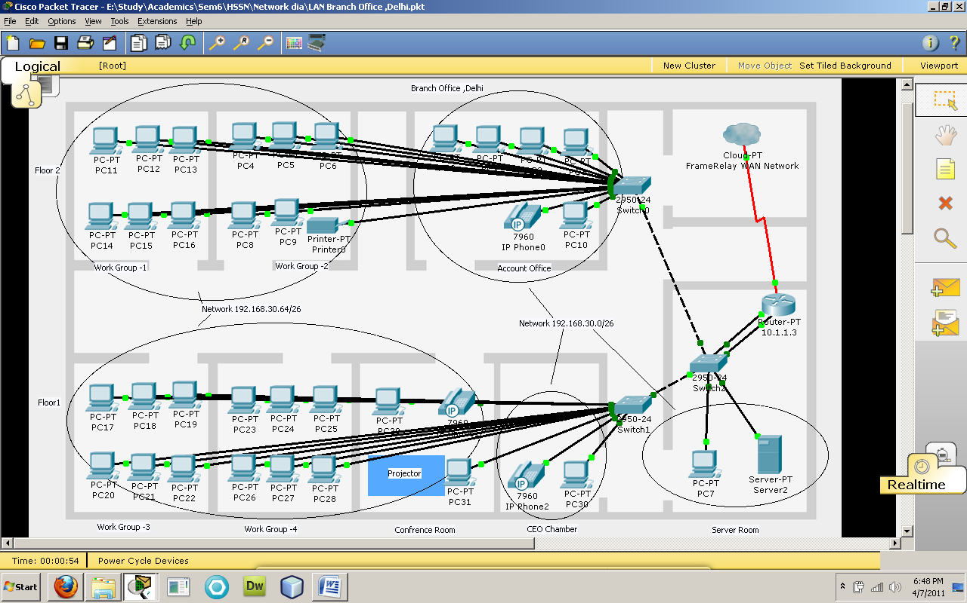
11.3 LAN 3– Branch office, Delhi, India
Figure6.Branch office LAN ,Delhi, India

11.4 Most Suitable Topology

For Headquarter
Topology - Hierarchical network Model i.e. Hybrid (Star + Mesh)
Benefits of the topology
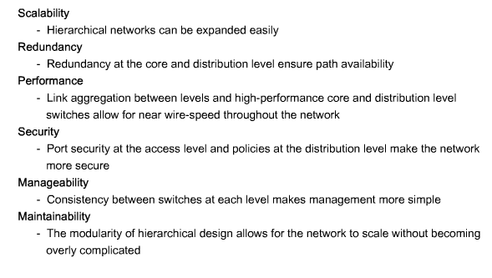
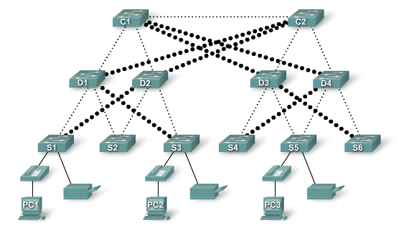
Figure7.Redundant links for assured availability

For Branch Office

Topology – Star Topology
Advantages of Star Topology: Branch offices ^{[7]}
- We can use less expensive twisted pair cable between server and the nodes.
- Adding and removing of the nodes are easy in star topology. It is very easy to add a new node to a network; it just needs to add a wire and the node with the central node.
- In a star topology each node is individually attached to the central hub. Therefore A break of cable would isolate only one node from the network, but would not affect the operation of the whole network.
- The problems can be easily located logically in a Star Topology and therefore is easy to troubleshoot also.
- It specifies the less use of cabling so it is also cost beneficial for the organisation.

11.5 Most Suitable Architecture: Client-Server Architecture

Comparison Chart of Client Server Vs Peer to Peer Network Architecture Model
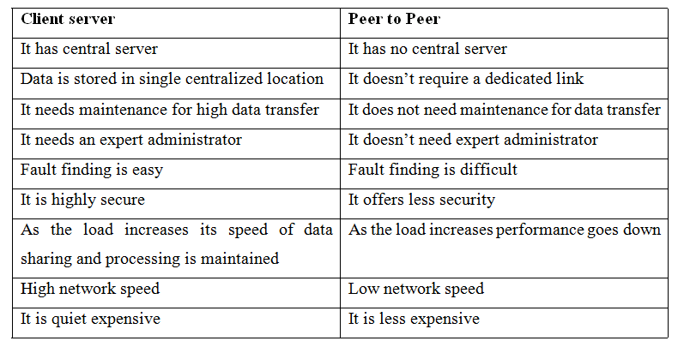
In this network scenario of ICT Resources Malaysia I have used client server model for network architecture because of the following reasons:
- When the data load or data requests are increasing then peer to peer network architecture goes down but in client server architecture speed is maintained and data sharing and processing will not be interrupted.
- As in client server model data is stored in single centralized position so it increases the flexibility and security of data.
- By the use of client server model more number of staff can use the network without the loss of performance which increases the scalability.
- Client server model is also appropriate for security purposes as we can install only one antivirus on main server, and this will detect all the attacks which will be occurred in the whole network.
- As I have to implement WAN for the company’s different locations so it needs a server which will only be provided by client server architecture.
- Since the network is large, fault finding and maintaining a peer to peer architecture will be very difficult.
- One more advantage is back up because as all the data stored is centrally it is easy to back up.

11.6 Most Suitable Transmission Media

  - Line connecting each PC to local switch is connected via UTP Cat 5
Cat-5 cable supports data speeds of 100 mbps or more. A standard Cat-5 cable can also reach 300 feet (100 meters)
Advantages of UTP cat5 Cable^{[8]}
Speed -A Cat 5 UTP cable can transmit data at speeds up to 100 Mbps, or megabits per second. Unless you are looking to play the latest, high-powered game or download large movie files, the 100 Mbps capability is reliable, quick and sufficient for transferring data at high speeds.
Compatibility-The Cat 5 UTP has a tip that connects to an RJ45 (standard Ethernet) port. RJ45 ports are standard on all computer towers and laptops---even Apples---allowing the Cat 5 cable to be used on machines that are several years old or brand new.
Size-Cat 5 UTP cables are approximately .17 inches in diameter; this smaller size allows cables to be installed quickly and efficiently, without taking up much room. This is especially beneficial when installing wires and cables in an older building.
Cost-Category 5 UTP cable is financially more sound than other cables on the market. It costs less than its brother cable, Cat 5e, and significantly less than the next up-and-comer in the cabling market, the Cat 6.
  - Line connecting each local switch to main switch/Switch-Switch/Switch-Router – UTP Cat 5e
- Cat-5e is enhanced Cat-5 cable that supports 1000 mbps or gigabit Ethernet.
- It can be used with 100 Base-T networks for long-distance runs of 1150 feet (350 meters).

  - Line connecting each Branch’s router to Service Provider’s Frame-relay network – T Carrier
T Carrier^{[9]}
T Carrier is a generic name for any of several digitally multiplexed carrier systems. T Carrier systems were originally designed to transmit digitized voice signals. Current applications also include digital data transmission. T1 and T3 are the most popular T Carrier links.
T-1- Used to connect Headquarter with Frame-relay network
T-1, also spelled T1, stands for Trunk Level 1. It is a digital transmission link with a total signaling speed of 1.544 Mbps (1,544,000 bits per second). T-1 is a standard for digital transmission in North America - the United States and Canada. It is part of a hierarchy of digital transmission pipes known generically as the DS (Digital Signal Level) hierarchy. T-1 equates to DS-1 in the DS hierarchy.
Advantages of T-1 link
- It is extremely reliable and high-performing.
- It is usually accompanied by excellent support services.
- It offers a constant and fast data transfer rate — about 1.5 MB per second
- Full duplex - Transmission and reception of data can take place simultaneously.
- Digital- T-1 is an all digital service. Data, analog voice, and analog fax are all converted into digital pulses (1s and 0s) for transmission on the line.
- It uses Time-division multiplexing techniques which have its own set of advantages.
Fractional T-1- Used to connect other two locations to the frame-relay network
Leasing a T-1 line means paying for the entire 1.544 Mbps bandwidth 24 hours a day, whether it is used or not. Fractional T-1 (FT-1) lets you lease any 64 kbps sub multiple of a T-1 line. For example, lease only six of the 64 kbps channels for an aggregate bandwidth of 384 kbps.

11.7 WAN Design

Technology Used – Frame-Relay

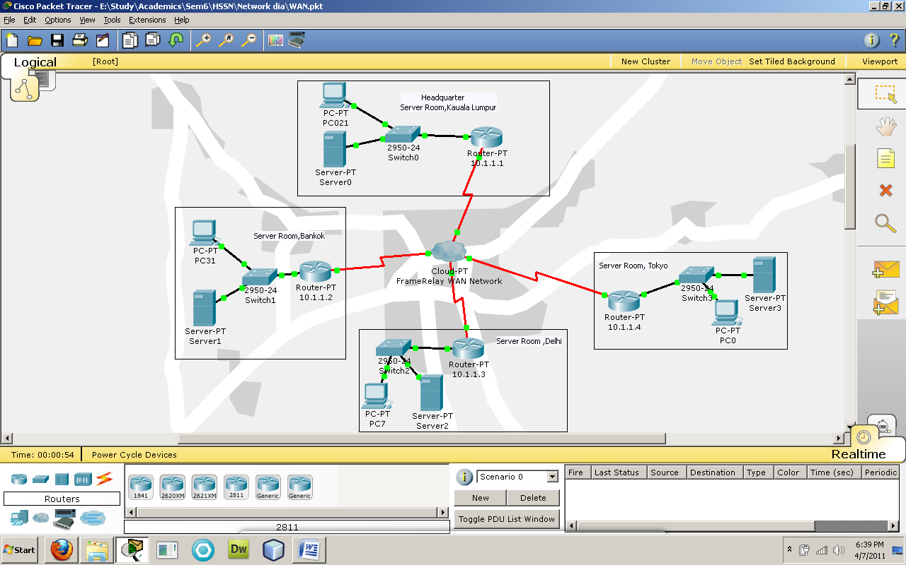
Figure 8– Frame-relay WAN network of ICT Resources Malaysia

Frame Relay in a Nutshell ^{[10]}
Frame Relay has ability to link devices across both Local Access Networks (LANs) and Wide Area Networks (WANs). It can deliver those capabilities at an extremely competitive price.
Frame Relay Service runs on a highly reliable network that is supported by redundant hardware components that have auto-switch capabilities. Redundant components throughout network switches include: processor cards, trunk cards and port cards
Frame Relay can provide speeds from 56kbps DS0 up to 43Mbps DS3 connections depending on the capability of the service provider's network.
Basic Concepts
When using Frame Relay for WAN connectivity a business customer purchases Frame Relay service from a service provider. The connection to the Frame Relay network is done by attaching a point-to-point link from the customer's DTE to the provider's DCE. This connects the customer to the provider's Frame Cloud. Once the connection to the Frame Cloud is in place at two or more of the the customer's sites PVC's can be set up to allow communication between the sites. The PVC's endpoints are identified with a DLCI. Once the connection is up the customer can monitor the status of the line using the functionality provided by the LMI.

Connection to Frame Relay Network
To connect its offices to the Frame Relay cloud ICT Resources Malaysia has purchased a mixture of full and fractional T-1 lines. A full T-1 line connects its Kauala Lumpur headquarters to the frame loud and fractional T-1 lines connect each of its offices situated in Delhi and Bangkok.

Equipment Required
Some Frame Relay providers will include customer equipment like DTE's and routers in the overall package price.

Justification/Advantages of Using Frame Relay Network
- The main advantage of Frame Relay over point-to-point leased lines is cost.
- Frame Relay can provide performance similar to that of a leased line, but with significantly less cost over long distances.
- The reason is because the customer only has to make a dedicated point-to-point connection to the provider's nearest frame switch. From there the data travels over the provider's shared network.
- The price of leased lines generally increases based on distance. So, this short-haul point-to-point connection is significantly less expensive than making a dedicated point-to-point connection over a long distance.
- Lower cost over distance makes Frame Relay is a good choice for ICT Resources Malaysia since it has offices located across the continent.

Disadvantages of Frame Relay

- The two main disadvantages of Frame Relay are slowdowns due to network congestion and difficulty ensuring Quality of Service (QoS). Because all of a provider's Frame Relay customers use a common network there can be times when data transmission exceeds network capacity.
- The difficulty ensuring QoS is due to the fact that Frame Relay uses variable-length packets. It is easier to guarantee QoS when using a fixed-length packet.
- To address the issue of potential congestion, ICT Resources Malaysia should be sure that service provider’s Committed Information Rate (CIR) is sufficient to meet the needs of their network. CIR is the minimum level of throughput that the provider guarantees and FDP should be delivering at least this amount of throughput even in times of heavy network load.
- ICT Resources Malaysia should also carefully examine their present and future quality of service needs. Is voice or video conferencing between sites is something on the horizon? If so, ICT Resources Malaysia may want to examine the ways in which Frame Relay equipment can prioritize traffic and determine if these mechanisms are sufficient for to meet their needs. If not, ICT Resources Malaysia may want to consider an alternative like ATM.

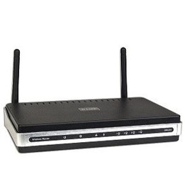
11.8 Most Suitable networking device

- D-link DIR-615 Router^{[11]}
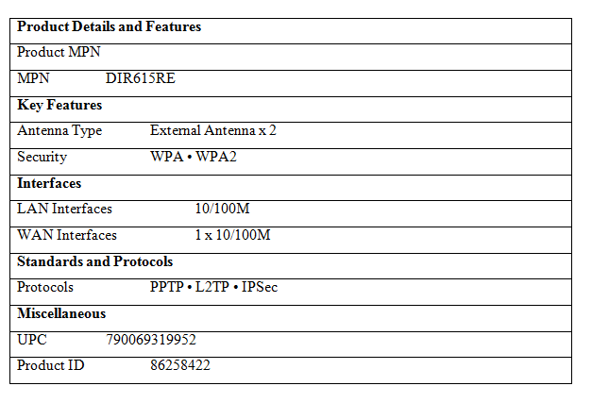
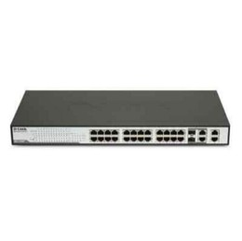
- D-Link Web Smart DES-1228 - Switch - 24 ports^{[12]}

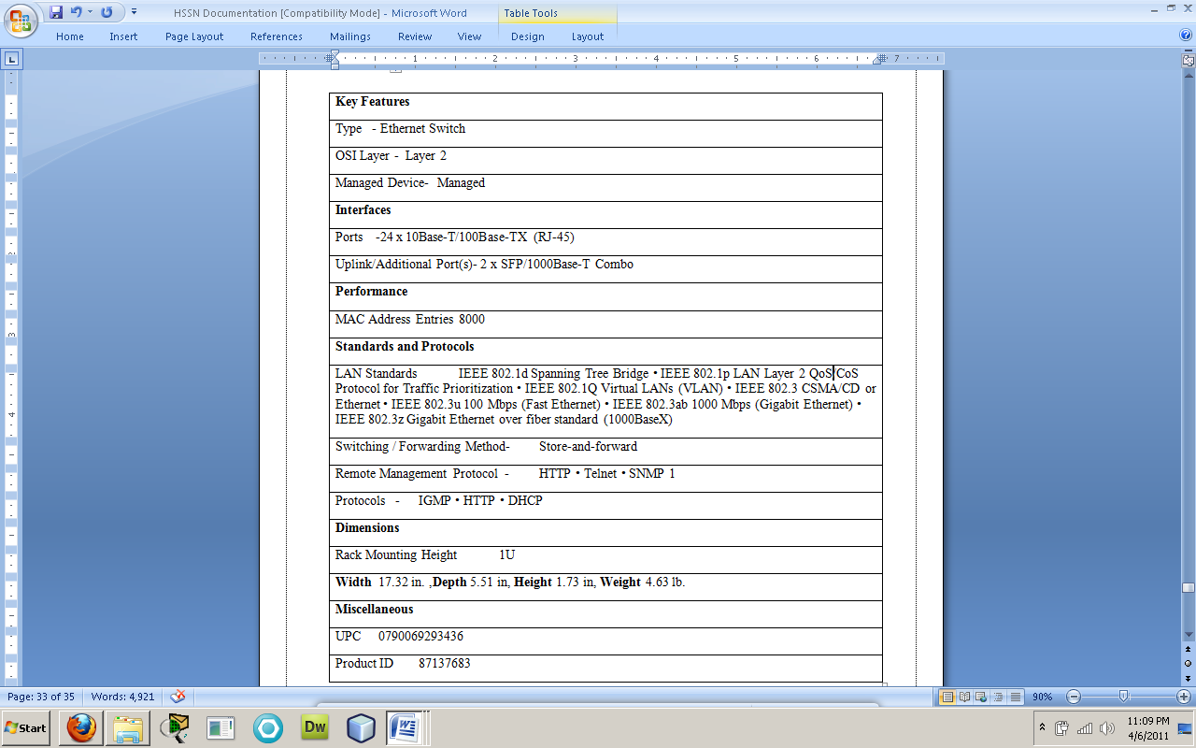

- NETGEAR ProSafe FS105 10/100 - Switch - 5 ports

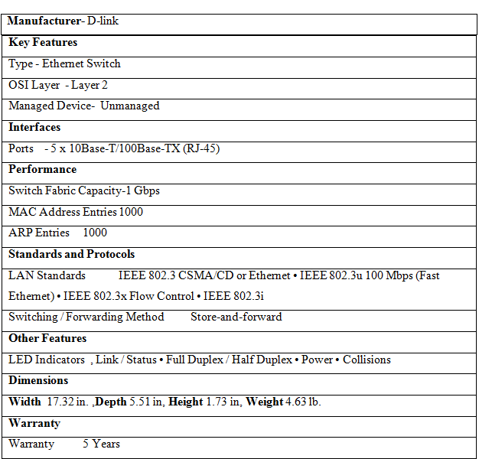

- IBM Think Server TD100x
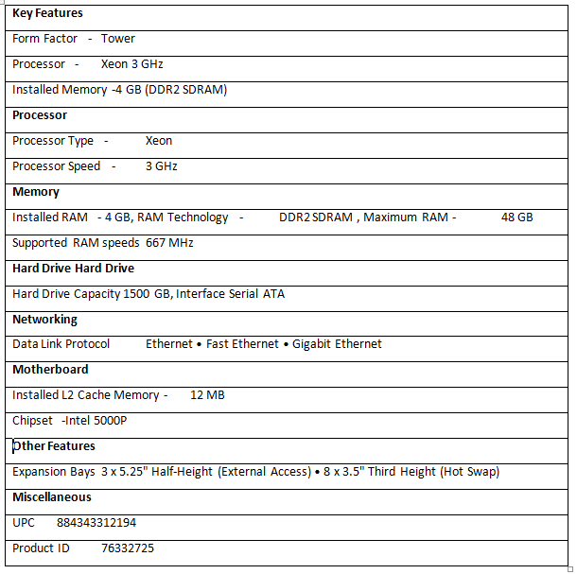
- Cable Used: Abergetty Ethernet CAT 5E Cable; Blue- 1000ft 350Mhz. UTP PVC Solid Cable
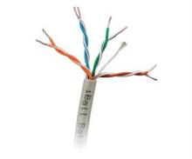
Features:
- Unshielded twisted pair
- Enhanced Cat. 5
- Solid 4 pair
- Guaranteed 24 AWG
- Meets all requirements for Gigabit Ethernet
- Exceeds the requirements of EIA/TIA 568B.2 & ISO/IEC 11801 standards
- Cabling Standards supports frequencies up to 100 MHz

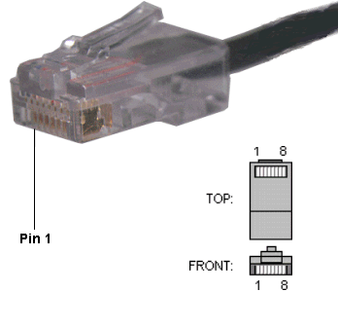
- CONNECTOR: RJ 45 CONNECTOR
- RJ45 standard specifies both the mechanical interface and a different wiring scheme which is often used for Ethernet and telephones
- RJ45 consists of two paired components: the male plug and the female socket. Each has eight equally-spaced conductors. On the plug, these conductors are flat contacts positioned parallel with the connector body.
- It is used as a standard connection for Gigabyte Ethernet Transmission.

12.0 Cost Estimation
LAN- Headquarter
Product | Product company | Quantity | Cost/item | Total cost
Server | IBM ThinkServer TD100x (420614U) | 1 | $2085 | $2085
Computer | IBM | 32 | $620 | $19804
Projector | BenQ | 1 | $850 | $850
Printer | Hp | 1 | $450 | $450
Ip phone | Cisco | 3 | $50 | $150
Switch (24 port) | D-link | 3 | $250 | $750
Switch (5 port) | Netgear | 3 | $45 | $135
Cat 5 UTP Cable | Abergetty Ethernet | 2000 ft | $0.053/ft | $106
Cat5eUTP Cable | Abergetty Ethernet | 500 ft | $0.07/ft | $35
RJ45 Connectors | - | 250 | $0.01 | $2.5
Total |  |  |  | $22917.5
WAN Connection^{[13]}
Service Provider - AT&T IP Enabled Frame Relay
Service | Router | Monthly cost
Full T1 (1.5 MB)- Headquarter | Yes | $ 391
Fractional T-1(786KB) | Yes | $200
Total |  | $591

13.0 Problems Expected With the Network

- Frame relay is a packet-based transport technology. Unlike ATM, it does not use cells of a fixed size. So video conferencing and VoIP communication may not be very much effective.
- Since our network uses class C private address i.e. 192.168.0.0/16 so in future if the size of branch office increases then we have to switch to class B or Class A private address.
- Since network is frame relay network so if we switch the branch location then we have to take reconnect Brach office to service provider’s office.
- Administrative Time Requirements: Proper maintenance of a network takes time and training. Depending on the size of the network you may need to hire administrative support or take some informal training of your own.
- Server Failures: When a server goes down the entire network will halt. Halt in the server is more productivity loss than any other computer.

14.0 Future Enhancement

- Scalability- Since we are using Star topology in network so we can spread our network any time without any hassle.
- Hierarchal Network (Hybrid) can be implemented in all the branch location if their network becomes time critical like Head office.
- Access Control list - We can implement more network security in the future by configuring ACL on the router according to organization policy.
- We can switch whole network scenario to wireless network.

15.0 Conclusion

As a network consultant I have designed and implemented the network by using proper methodology and consistency. I have designed the requirements as per the specification and as ICT Malaysia was ready to invest good amount of money in this project so I have provided them the best I have and suggested that scenario which will increase their productivity and business with less expenses.

Word Count -3682 (Excluding table data)

16.0 References

16.1 Websites
- http://searchnetworking.techtarget.com/definition/network (Accessed on March 17, 2011)
- http://compnetworking.about.com/od/basicnetworkingconcepts/a/network_types.htm (Accessed on March 17, 2011)
- http://www.buzzle.com/articles/advantages-and-disadvantages-of-computer-networks.html (Accessed on March 20, 2011)
- http://www.nationalserviceresources.org/internet-connection-options (Accessed on March 21, 2011)
- http://fcit.usf.edu/network/chap5/chap5.htm (Accessed on March 21, 2011)
- http://www.wisegeek.com/what-is-client-server-architecture.htm (Accessed on March 22, 2011)
- http://www.buzzle.com/articles/star-topology-advantages-and-disadvantages.html (Accessed on March 22, 2011)
- http://www.ehow.com/list_5889725_advantages-category-utp-cable.html#ixzz1IlPh9Hbc (Accessed on March 20, 2011)
- http://www.techfest.com/networking/wan/tcarrier.htm (Accessed on March 22, 2011)
- http://www.happy-monkey.net/papers/frame-relay-paper.pdf (Accessed on March 25, 2011)
- http://www.shopping.com/D-link-D-Link-DIR-615-RE-300Mbps-802-11n-Wireless-LAN-Firewall-4-Ports-Router/info#keyFeatures (Accessed on March 25, 2011)
- http://www.shopping.com/xPF-D-link-D-LINK-WEB-SMRT-24PT-10-100-SWCH-4-GIG-COPPER-2-SFP-W-PO (Accessed on March 29, 2011)
- http://www.corp.att.com/ap/services/data/ipefratm.html (Accessed on April 4, 2011)

16.3 Books
- Behrouz A Frozen (2006). Data Communications & Networking. 4th ed. India: Tata McGraw Hill Publishing Company Ltd. p445-466.

- Andrew S. Tanenbaum (2003). Computer Networks. 4th ed. U.S.A: Prentice Hall. P113-117

- L. Peterson and B.S. Davie (1996). Computer Networks: A Systems Approach. Morgan Kaufmann. 7th ed. UK: Prentice Hall. P245-266.

Tool used for drawing – Packet Tracer, Cisco networks Pvt. Ltd

